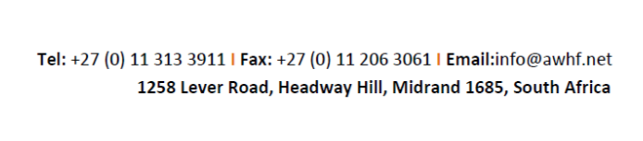

Moses Mapesa Research Grant
Application deadline: 29 July 2022
APPLICATION FORM

A- Identity of applicant
Surname: |  |  |  |  |  |  |  | Other name(s):
Sex: Male □ Female □ |  |  | Age: |  |  |  |  | Nationality:
Physical Address: [please state country]

Telephone: |  |  |  |  | Email (mandatory):
B- University details
University name:

Currently registered? |  | Yes / No |  |  |  |  | Full time / part time?
Master or Doctoral programme
Degree title:
Degree length: |  |  |  |  |  |  | From: dd / mm/ yyyy |  | To: dd / mm / yyyy
Address of institution:

Telephone: |  |  | Email:
Description of degree components:

Please state all types of funding/grant/scholarship support you have received or will be receiving for this research:

C- Academic background of applicant
Discipline:

Academic/professional Qualifications:
D-Professional background of applicant
Field:
Work/professional experience:
E- Relevance of research
- Briefly describe the link between your current or past experience with the research topic

- Summarise your research project
- Expected Results and Deliverables

- Name of World Heritage Site
F- English language proficiency -Please tick your proficiency in English
Languages | Fluent |  |  |  |  | Moderate |  |  |  | Low
Speak
Read
Write
G- Confirmation from university supervisor/authority
I, the undersigned, confirm that. ……………………………………is or will be registered for a ………………………. at the ……………………………………..University from…………………to the ……………………….
Position and name:

Institution/Organisation (Name and contact details):

Signature/Stamp:

Date:
H- Certification by the applicant
I, the undersigned, certify that the information above is true, complete and correct to the best of my knowledge.

Date: Signature

The complete application package (letter of motivation, curriculum vitae, transcript, completed application form and research proposal) should be sent by 29 July 2022 via email to: AWHFResearchGrant@gmail.com and cc info@awhf.net

